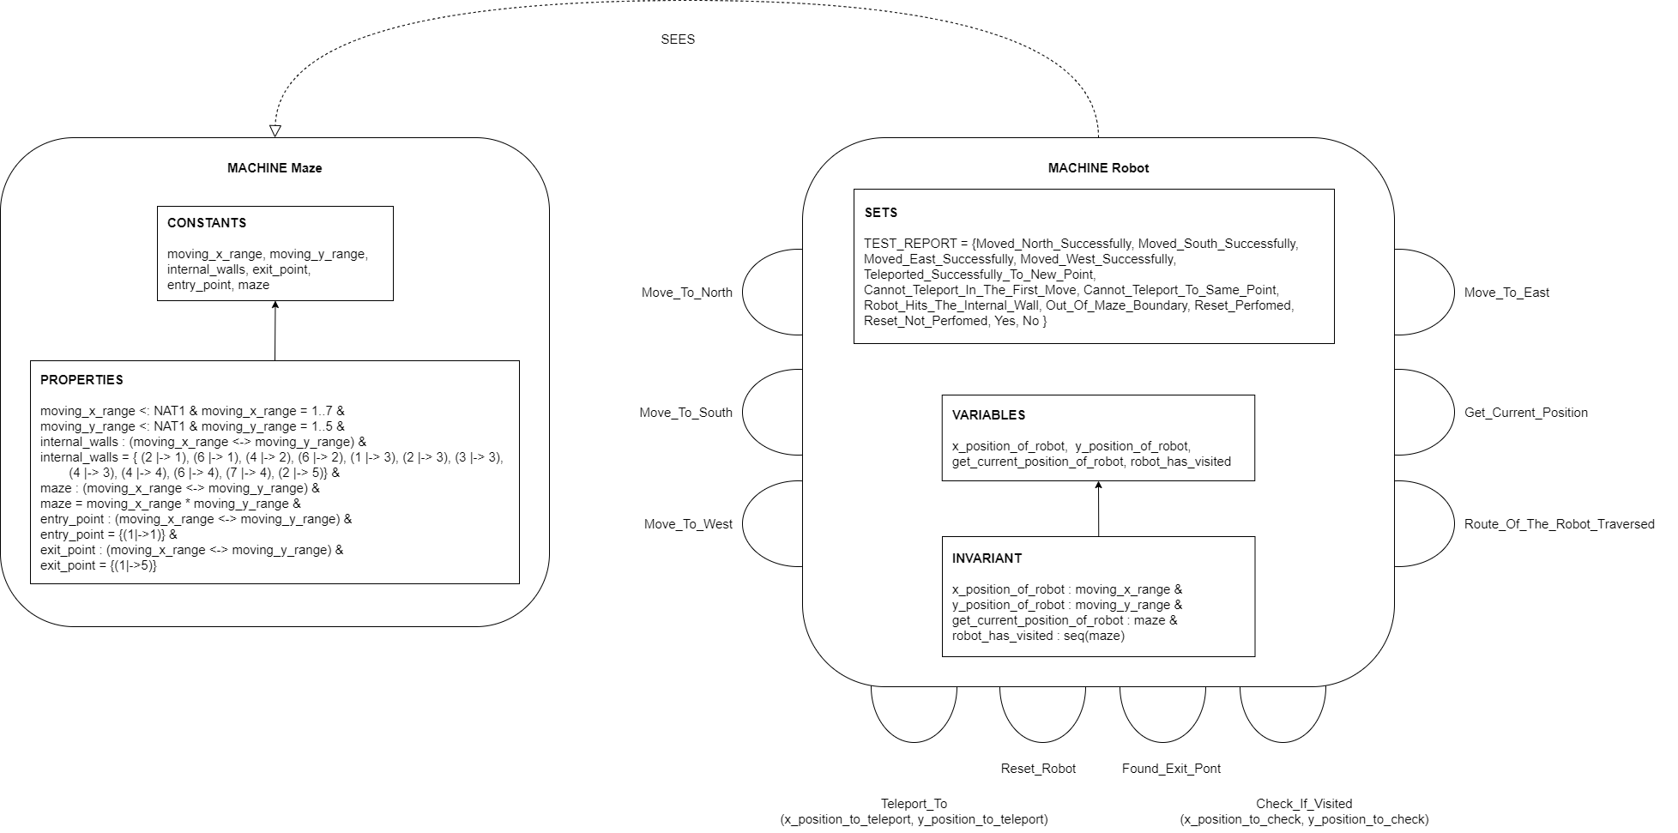**Structure Diagram**

**State ‘INVARIANTS’ description**

* x_position_of_robot : moving_x_range
  + This variable gets the ‘x’ position of the robot. The values that are to be assigned are from the constants in the Maze.mch. The type of the moving_x_range are natural number from 01 to 07. ‘x_position_of_robot’ variable collects the x coordinates of the positions of the robot either in which it is or the new position and verifies it with the ‘moving_x_range’ constant which depicts the cartesian of the maze. NAT1 was used to define the constant ‘moving_x_range’ because the cartesian of the maze begins horizontally from 01 and the maximum x direction is of 07 boxes.
* y_position_of_robot : moving_y_range
  + This variable gets the ‘y’ position of the robot. The values that are to be assigned are from the constants in the Maze.mch. The type of the moving_y_range are natural number from 01 to 05. ‘y_position_of_robot’ variable collects the y coordinates of the positions of the robot either in which it is or the new position and verifies it with the ‘moving_y_range’ constant which depicts the cartesian of the maze. NAT1 was used to define the constant ‘moving_y_range’ because the cartesian of the maze begins vertically from 01 and the maximum y direction is of 05 boxes.
* get_current_position_of_robot : maze
  + This variable gets the current position of the robot. Here, it is stored as a relation of the x coordinates and the y coordinates mapping them using a maplet relation.
* robot_has_visited : seq(maze)
  + The visited coordinates of the maze are stored in this variable. The variable gets updated by appending the new coordinates to the tail of the sequence in-order to maintain the route in which the robot has travelled.